**Lab - 9**

**SQL query based on DDL – 1**

1. **Write a query to create a table emp with empno, ename, designation, and salary**

CREATE TABLE emp (

empno INT PRIMARY KEY,

ename VARCHAR(100),

designation VARCHAR(50),

salary DECIMAL(10, 2));

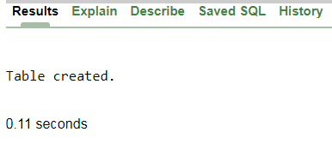

1. **Write a query for create a from an existing table with all the fields**

CREATE TABLE emp2 AS

SELECT * FROM emp;





1. **Write a query for create a from an existing table with selected fields**.

CREATE TABLE emp3 AS

SELECT employee_id,first_name

FROM employees;



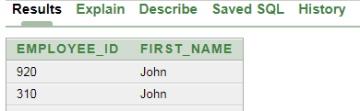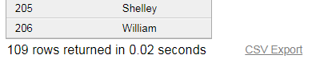

1. **Write a query for create a new table from an existing table without any record.**

CREATE TABLE emp4 AS

SELECT * FROM employees

WHERE 1 = 0;

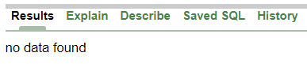

1. **Write a Query to Alter the column EMPNO.**

ALTER TABLE emp3

ADD location_id NUMBER(10);

